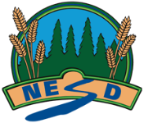
North East School Division
Unpacking Outcomes
Module 99A, B, C: Extended Study (Optional)
Unpacking the Outcome
Outcome (circle the verb and underline the qualifiers)
KNOW | UNDERSTAND | BE ABLE TO DO
Vocabulary: | That
ESSENTIAL QUESTIONS

